Bootstrap

Bootstrap is often described as a way to "build fast, responsive sites" and it is a "feature-packed, powerful, and extensible frontend toolkit".

Some people refer to it as a "front-end" framework, and some are trying to be more specific by referring to it as a "CSS framework" or a “CSS library”.

So, what is Bootstrap?

Simply put, Bootstrap is a library of CSS and JavaScript code that you can combine to quickly build visually appealing websites.

Modern web development is all about **components**. Small pieces of reusable code that allow you to build websites quickly. Bootstrap comes with multiple components for very fast construction of multiple components, or parts of components.

Another important aspect of modern development is **responsive grids** which allow web pages to adapt their layout and content depending on the device in which they are viewed. Bootstrap comes with a pre-made set of CSS rules for building a responsive grid.

Bootstrap is very popular amongst developers as it saves development time and provides a way for developers to build visually appealing prototypes and websites.

Bootstrap saves significant time because all the CSS code that styles its grid and pre-built components is already written. Instead of having to have a high level of expertise in various CSS concepts, you can just use the existing Bootstrap CSS classes to produce nicely-looking websites. This is indispensable when you need to quickly iterate on website layouts.

Once you know how Bootstrap works, you’ll have enough knowledge to tweak its styling and a whole new world of development opens up to you.

Since Bootstrap is so popular, understanding how to work with it is a prerequisite in many web development companies. Additionally, you can be safe in knowing that both you and your team members have a common design system and you don't have to spend time deciding how to build one. You are free to jump from team to team, from project to project, even from one company to another, and you don't need to re-learn "their way of doing things".

All of these points make investing time to learn Bootstrap a great way to boost your web development skills. In this lesson, you’ll be introduced to the core concepts of Bootstrap and learn how to build web pages using it.

# Using Bootstrap documentation

Bootstrap comes with detailed documentation on setting up and using the features available in its library. The documentation is clear and has many code examples to help you get started.

In this reading, you'll explore the frequently used documentation sections.

The documentation for Bootstrap is currently available at the following link.

<https://getbootstrap.com/docs>

## Navigating the documentation

The sidebar on the webpage allows you to navigate through the different sections of the documentation. There is also a search box if you need to search for a specific piece of information.

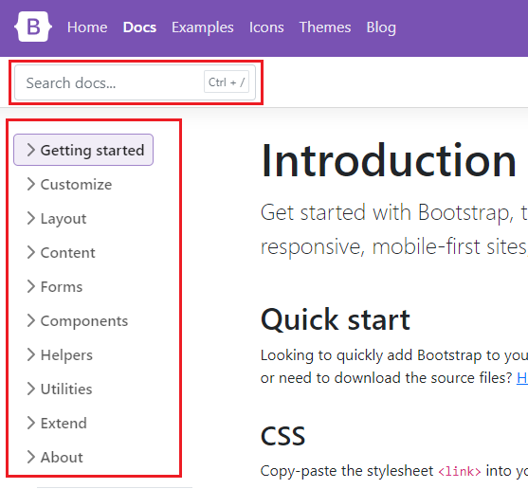

## Layout

The layout section of the documentation describes how to use the grid system of Bootstrap. This covers what you've learned so far and includes more advanced usage such as offsets, column alignment, auto-layout and variable width columns.

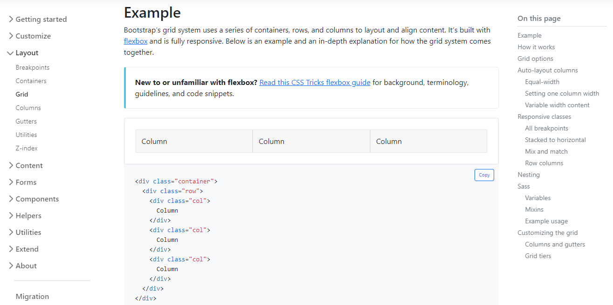

## Content

The content section of the documentation describes Bootstrap's default text styling and how to use responsive images and tables. You've learned the basics of these earlier on and this section goes into further detail.

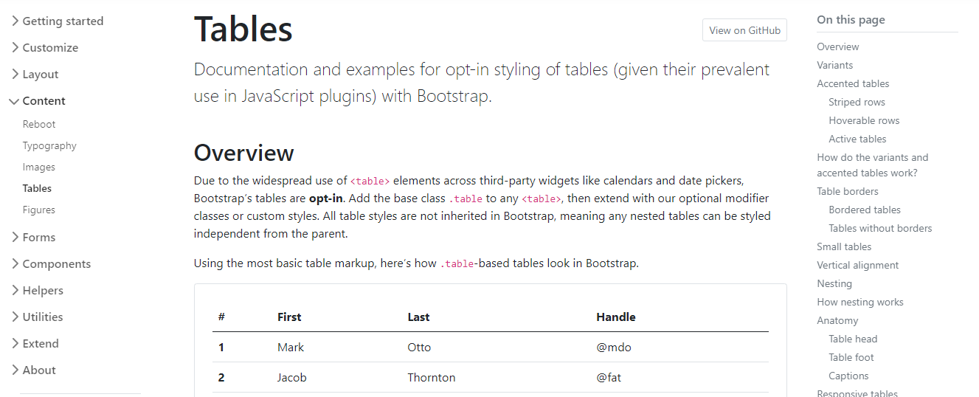

## Forms

The forms section of the documentation describes how to build forms using Bootstrap's styles. The library has many CSS rules to improve your form's user interface and experience. Below are some features you'll frequently use as a developer:

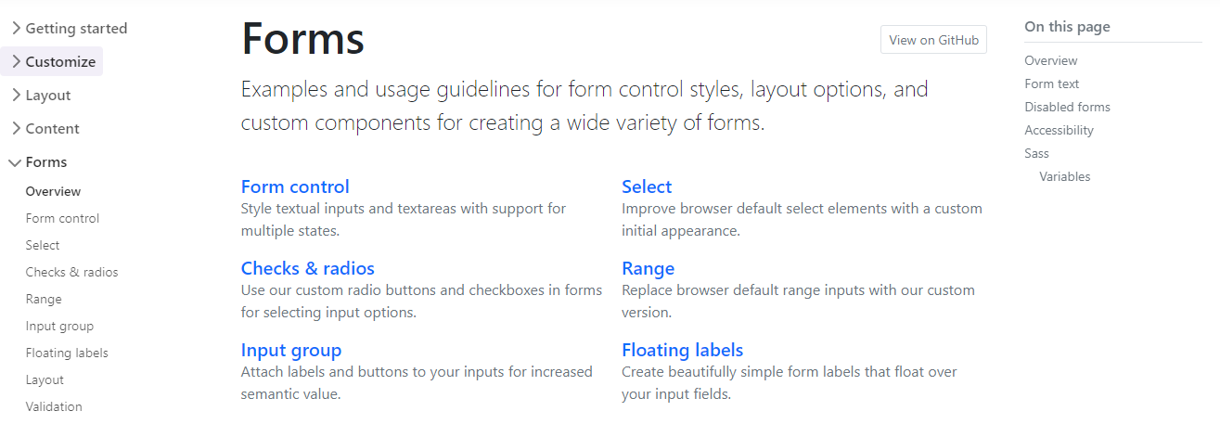

### Form Styling

Bootstrap includes CSS rules to improve the visual style of input elements.

For example:

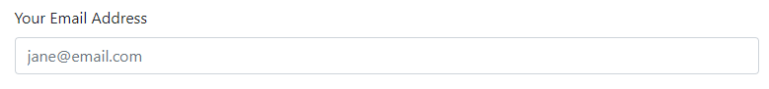

This table outlines the different HTML form elements and which Bootstrap CSS class should be used for them.

| **Form Element** | **CSS class** |
| --- | --- |
| **input** | **form-control** |
| **input type="checkbox"** | **form-check-input** |
| **input type="radio"** | **form-check-input** |
| **input type="range"** | **form-range** |
| **select** | **form-select** |

Using these CSS classes will style the elements appropriately for different input types, sizings and states. More information is available on the [Forms documentation page](https://getbootstrap.com/docs/5.0/forms/overview/).

### Switches

If you've used an app on your mobile device, you're probably familiar with the switch input type.

Bootstrap Doc Switches

Bootstrap includes CSS rules to style checkbox input elements as switches.

To do this:

1. Add the **input** to a **div** element.
2. On the **div** element, apply the **form-check** and **form-switch** CSS classes.
3. On the **input** element, add the **form-check-input** CSS class.

<div class="form-check form-switch">

  <input class="form-check-input" type="checkbox">

</div>

More information is available in the [Switches section of the documentation](https://getbootstrap.com/docs/5.0/forms/checks-radios/#switches).

### Input Groups

Input groups are useful for providing additional content to the input field. For example, if you wanted to request the user to input a US dollar amount, you can use an input group to show the dollar symbol and cents amount.

Bootstrap Input Groups 

To do this:

1. Add the **input** to a **div** element.
2. Apply the **input-group** CSS classes on the **div** element.
3. Add a **span** element before and/or after the **input** element and apply the **input-group-text** CSS class to it. The text content is then added inside the **span** element.

<div class="input-group">

  <span class="input-group-text">$</span>

  <input type="text" class="form-control">

  <span class="input-group-text">.00</span>

</div>

More information is available on the [Input Groups documentation page](https://getbootstrap.com/docs/5.0/forms/input-group/).

### Floating Labels

Floating labels help provide form information to the user as part of the input itself. These are different from regular form placeholders. The information stays visible if the user is interacting with the element or if the element has content.

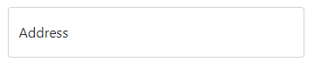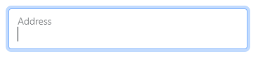

To do this, add the **input** to a **div** element. On the **div** element, apply the **form-floating** CSS classes.

<div class="form-floating">

  <input type="email" class="form-control" id="addressInput" placeholder="Address">

  <label for="addressInput">Address</label>

</div>

More information is available on the [Floating Labels documentation page](https://getbootstrap.com/docs/5.0/forms/floating-labels/)

## Components

As you have learned, Bootstrap comes with many pre-made UI elements and styles to help speed up your development.

Some of these components require Javascript to work, while others only require CSS classes applied to HTML elements. The Components section of the documentation explains these requirements on each component page and provides many code examples.

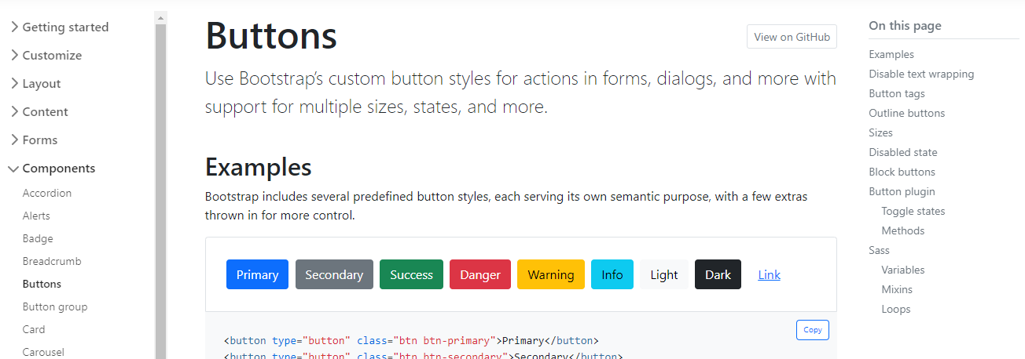

## Conclusion

Now that you are familiar with how to use the Bootstrap documentation, maybe try some new components and styles on a webpage that you've previously built.

# Other CSS frameworks and libraries

As a developer, you'll use many CSS libraries and frameworks throughout your career. As you move on to different projects and as technologies advance, knowing what solutions are available is critical. While Bootstrap is one of the most popular CSS libraries, many others are available, each with different purposes, designs and technical approaches. This reading will introduce you to other popular CSS libraries and frameworks.

### Foundation

[Official Website](https://get.foundation/)

Foundation is a framework for building user interfaces similar to Bootstrap. It is used by many large companies such as Pixar, Polar and Sonos. One prominent feature of Foundation is that it can be used to style content for sending via email.

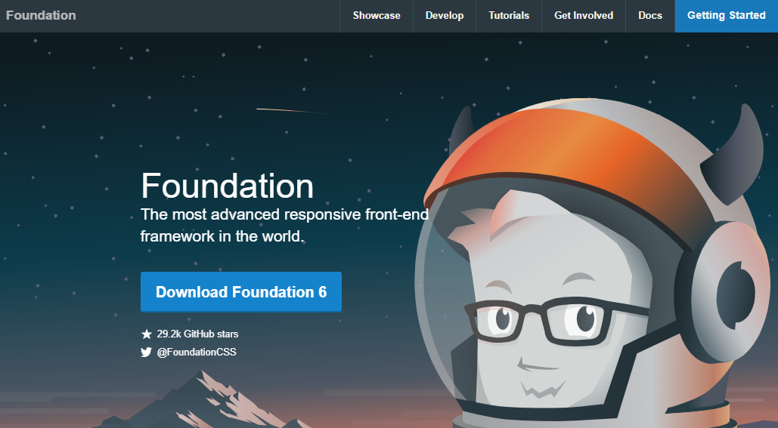

### Pure.css

[Official Website](https://purecss.io/)

Pure.css is another library for building user interfaces. While it doesn't have as many features as Bootstrap, it is designed to be minimal in file size. Smaller file sizes improve loading times for web pages as there is less data to transfer from the web server. If your next project is focused on minimal loading time, this library is worth considering.

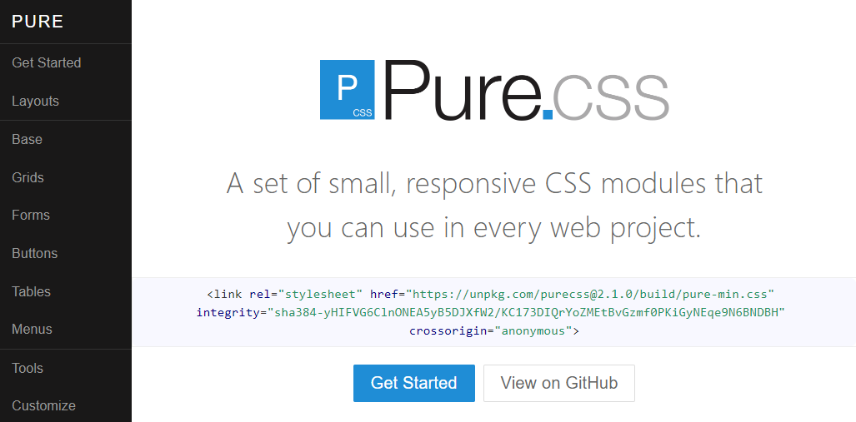

### Tailwind CSS

[Official Website](https://tailwindcss.com/)

Tailwind CSS is a CSS framework that uses a utility-based approach for its CSS rules. This means that the framework provides many CSS classes with a single purpose. For example, the CSS class pt-6 sets the padding-top CSS property to 6 pixels. This means that you can be precise in applying styling to your HTML without writing CSS. The advantage to this is that it is more flexible for customizing your webpage's design using the framework. However, the disadvantage is that if multiple developers are working on a project, it could lead to inconsistent design if the team is not strict on its design rules.

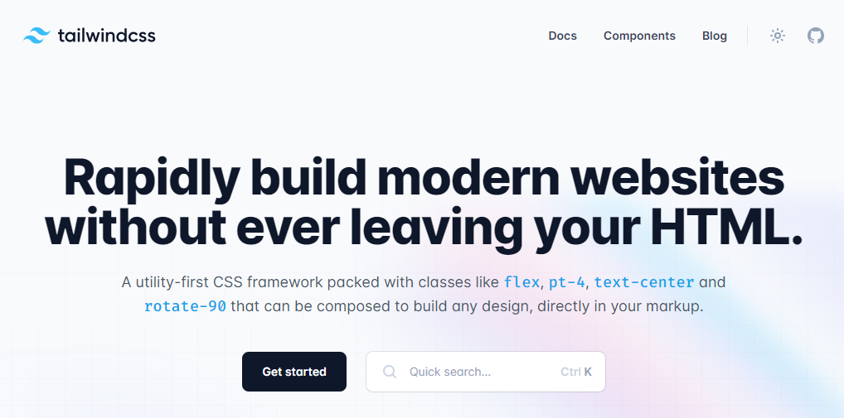

### UIKit

[Official Website](https://getuikit.com/)

UIKit is a lightweight CSS framework featuring a small set of responsive components. Its simple design allows developers to easily customize the style rules and visuals.

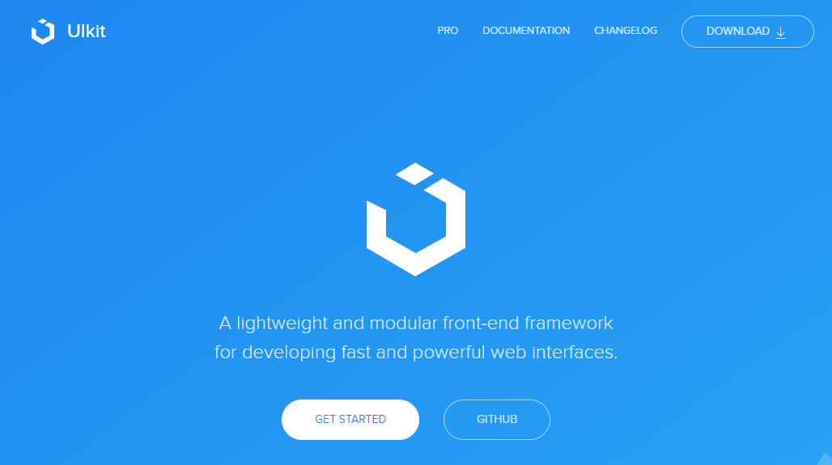

### MVP.css

[Official Website](https://andybrewer.github.io/mvp/)

MVP.css is a small CSS library that automatically styles HTML elements without needing to apply CSS classes to them. The library aims to allow a developer to quickly prototype a user interface without worrying about the final design, while still being visually appealing. MVP comes from the technical term Minimal Viable Product, a product with sufficient features to demo to customers or other business stakeholders.

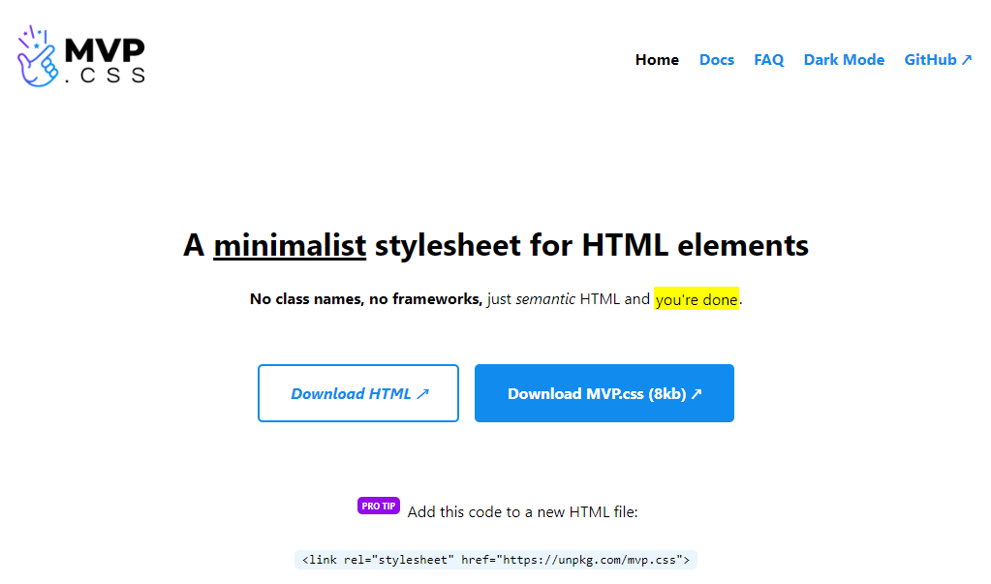

### Conclusion

If you're curious to learn more about these frameworks, their websites feature set up guides, tutorials and documentation to get started. It is a good exercise to compare and contrast different libraries and frameworks to understand different workflows available to you as a developer.

# Additional Resources

**Bootstrap Official Website**

<https://getbootstrap.com/>

**Bootstrap 5 Foundations by Daniel Foreman**

<https://www.amazon.com/Bootstrap-Foundations-Mr-Daniel-Foreman/dp/B0948GRS8W/>

**Responsive Web Design with HTML5 and CSS by Ben Frain**

<https://www.amazon.com/Responsive-Web-Design-HTML5-CSS/dp/1839211563/>

**Bootstrap Themes**

<https://themes.getbootstrap.com/>